ภาคผนวก ข

CVE

What Is CVE?
Common Vulnerabilities & Exposures (CVE) is a list or dictionary that provides common names for publicly known information security vulnerabilities and exposures. Using a common name makes it easier to share data across separate databases and tools that until now were not easily integrated. This makes CVE the key to information sharing. If a report from one of your security tools incorporates CVE names, you may then quickly and accurately access fix information in one or more separate CVE-compatible databases to remediate the problem.

CVE is:
- One name for one vulnerability or exposure
- One standardized description for each vulnerability or exposure
- A dictionary rather than a database
- How disparate databases and tools can “speak” the same language
- The way to interoperability and better security coverage
- A basis for evaluation among tools and databases
- Accessible for review or download from the Internet
- Industry-endorsed via the CVE Editorial Board
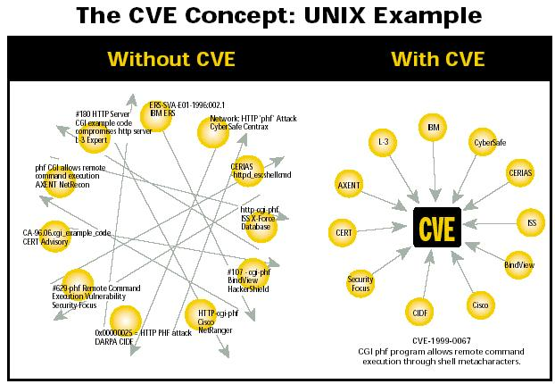

Why CVE?
Most information security tools include a database of security vulnerabilities and exposures; however, there is significant variation among them and no easy way to determine when different databases are referring to the same problem. The consequences are potential gaps in security coverage and no effective interoperability among the disparate databases and tools. In addition, each tool vendor currently uses different metrics to state the number of vulnerabilities or exposures they detect, which means there is no standardized basis for evaluation among the tools. With a standard list of vulnerabilities and exposures such as CVE, your databases and tools can “speak” to each other. And, you’ll know exactly what each tool covers because CVE provides you with a baseline for evaluating the coverage of your tools. This means you can determine which tools are most effective and appropriate for your organization’s needs. In short, CVE-compatible tools and databases will give you better coverage, easier interoperability, and enhanced security. CVE is also endorsed by leading representatives from the information security community. CVE’s content results from the collaborative efforts of the CVE Editorial Board, which includes representatives from more than 15 information ecurity-related organizations.
Who Is the Editorial Board?
The CVE Editorial Board includes members from numerous information security-related organizations including commercial security tool vendors, members of academia, research institutions, government agencies, and other prominent security experts. Through open and collaborative discussions, the Board identifies which vulnerabilities or exposures are included in CVE, then determines the common name and description for each entry. The MITRE Corporation created the Editorial Board, moderates Board discussions, and provides guidance throughout the process to ensure that CVE serves the public interest. Archives of Board meetings and discussions are available for review on the CVE web site. Other information security experts will be invited to participate on the Board on an as-needed basis based upon recommendations from Board members.

What It Means To Be CVE Compatible
“CVE-Compatible” means that a tool, Web site, database, or other security product uses CVE names in a manner that allows it to be cross-referenced with other products that employ CVE names. “CVE compatible” means: _ CVE SEARCHABLE — A user can search using a CVE name to find related information. _ CVE OUTPUT — Information is presented that includes the related CVE name(s). _ ACCURACY — The provider has made a good faith effort to ensure that CVE names are used accurately in the product. Different tools provide different coverage/cross-referencing of CVE names e.g., some tools might cover Unix, while others cover Windows NT). You will need to evaluate any CVE-compatible products based upon your organization’s specific requirements. Visit the site for the most urrent information regarding the types and availability of CVE-compatible products.

The CVE Naming Process
The process begins with the discovery of a potential security vulnerability or exposure. The informations then assigned a CVE candidate number. The Editorial Board discusses the candidate and votes on hether or not it should become a CVE entry. If the candidate is accepted, it is entered into CVE and is published on the CVE Web site. Candidates can be searched on the site, but the CVE and candidates lists are separate.

